Ch 3.1-3.4 Guided Notes (COMPLETE)

Represent Distributions of Quantitative Variables with Histograms

[1.1] Record times for you and your partner to the nearest second
Yours: | Partner's:

[3.1; 3.2] Draw histograms to represent the distribution of the 20 data points below
4, 5, 10, 11, 12, 15, 17, 18, 19, 19, 20, 20, 21, 25, 30, 30, 36, 39, 47, 50

binwidth = 2 | binwidth = 10
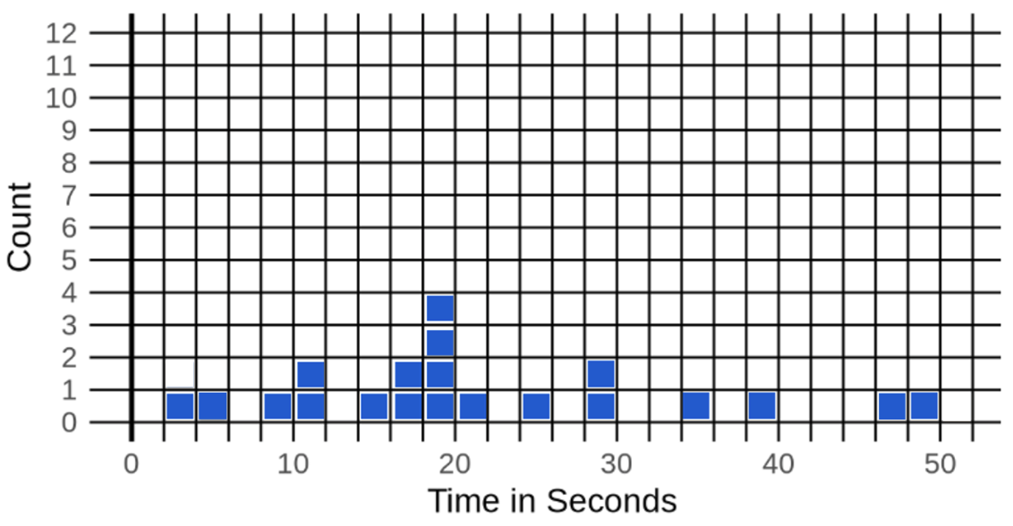 | 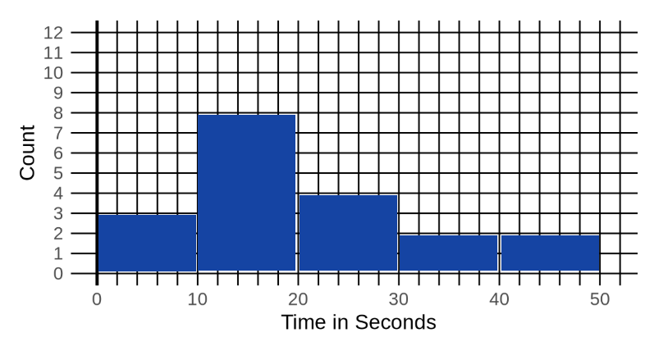

[4.2, 4.3] Write the R code to create the two histograms above
binwidth = 2: gf_histogram(~ time_standing_on_left_leg, boundary=0, binwidth=2)

binwidth = 10: gf_histogram(~ time_standing_on_left_leg, boundary = 0, binwidth = 10)

[5.2] Write the R code to make a histogram of time_standing_on_left_leg in the census dataset
gf_histogram(~ time_standing_on_left_leg, data = census)

[5.7] What's a bin? What's a binwidth?
bin sets how many bins | binwidth sets how wide (or skinny) the bin is

What is the relationship between the number of bins and binwidth?
more bins means a smaller binwidth; larger binwidth means fewer bins (an inverse relationship)

[6.1] Describe the shape, center, spread, and weird things in the distribution of time_standing_on_left_leg from census
shape: skewed (lots of data in one place and a few stragglers in the "tail")
center: maybe less than 100
spread: the range goes from 0 to 600; most of the times are less than 100

